Product Requirements
Team | topG

Brief problem statement
Our goal is to develop a Snake game using the Pygame library. The game will provide an enjoyable and challenging gaming experience for players. Players will control a snake to navigate and collect food while avoiding collisions with the snake's own body and boundaries. The game will keep track of the player's score and provide a user-friendly interface.

System requirements
The solution should be developed using Python programming language and the Pygame library. It should be compatible with Windows, macOS, and Linux operating systems. The game should have a graphical user interface (GUI) with visually appealing graphics and animations.

Users profile
The system is targeted towards casual gamers of all ages. Users should have basic computer literacy and familiarity with keyboard controls. No prior experience with the Snake game or Pygame library is required. The game should provide clear instructions and an intuitive user interface to ensure a smooth and enjoyable gaming experience for users of varying skill levels.

Feature requirements (user stories)

No. | User Story Name | Description | Release
 | Snake Movement | As a player, I want to be able to control the snake's movements using arrow keys, so that I can navigate through the game screen. | R1
 | Eat food | As a player, I want the snake to be able to eat the food on the screen when it overlaps with it, so that I can score points and grow the snake. | R1
 | Display Score | As a player, I want the game to keep track of my score and display it on the game screen, so that I can see my current score while playing. | R1
 | Game over | As a player, I want the game to end and display the score when the snake touches the walls ,itself or the obstacles, so that I know the game is over and can see my final score. | R1
 | Difficulty Levels | As a player, I want to choose before starting the game the level of difficulty :easy,medium or hard. | R2
 | Sound effects | As a player, I want the game to have sound effects for actions such as eating food, hitting walls, and other in-game events, so that I can have an immersive gaming experience. | R2
 | Menu | As a player, I want the game to have a menu where I can start the game, pause/resume, and reset the game, so that I can easily navigate through different game options. | R2
 | Error handling | As a player, I want the game to handle errors gracefully, such as handling invalid input and memory errors, so that I can have a smooth gaming experience without unexpected crashes or issues. | R3
 | Documentation | As a developer, I want to create comprehensive documentation including user manuals, source code documentation, and project reports, so that users and future developers can understand and maintain the game effectively. | R3

Use case diagram
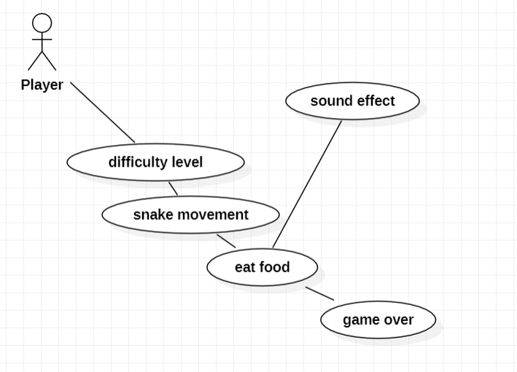

Use case description

Use Case Number: |  | UC-01
Use Case Name: |  | Snake Movement
Overview: |  | This use case allows the player to control the movements of the snake in the game using arrow keys.
Actor(s): |  | Player
Pre condition(s): |  | The game is running and the player has control over the snake.
Scenario Flow: |  | Main (success) Flow: The player starts the game and enters the game screen.  The player uses the arrow keys to control the direction of the snake.  The game updates the snake's position based on the player's input.  The player continues to navigate the snake across the game screen.  The player can change the direction of the snake by pressing the corresponding arrow key.  The game continues until the snake touches the walls or itself, triggering the game over condition..
Post Condition: |  | The snake's movements are controlled by the player's input, and the game responds accordingly by updating the snake's position on the game screen.
 | Use Case Number: |  | UC-02
 | Use Case Name: |  | Eat food
 | Overview: |  | This use case allows the snake to eat the food when it overlaps with it, resulting in score increment and snake growth.
 | Actor(s): |  | Player
 | Pre condition(s): |  | The snake is positioned on the game screen, and there is food available.
 | Scenario Flow: |  | Main (success) Flow:  The player controls the snake's movements to navigate it across the game screen.  The snake encounters the food on the game screen.  The snake overlaps with the food, triggering the "eat" action.  The game increments the player's score.  The snake grows longer by one unit.  The game generates new food at a random location on the game screen.  The player continues controlling the snake's movements.
 | Post Condition: |  | The snake successfully eats the food, the player's score increases, and the snake grows longer.

Use Case Number: | UC-03
Use Case Name: | Display Score
Overview: | This use case displays the player's score on the game screen during gameplay.
Actor(s): | Player
Pre condition(s): | The game is running, and the player has control over the snake.
Scenario Flow: | Main (success) Flow:  The player starts the game and enters the game screen.  The game initializes the score counter with a starting value of 0.  The player controls the snake's movements and interacts with the game.  The game updates the score whenever the player eats food and increments it accordingly.  The updated score is displayed on the game screen, either as a numeric value or a visual representation.  The score remains visible to the player throughout the gameplay.
Post Condition: | The player's score is continuously displayed on the game screen.

Use Case Number: | UC-04
Use Case Name: | Game over
Overview: | his use case handles the game over condition when the snake touches the walls or itself, ending the game and displaying the final score.
Actor(s): | Snake,Player
Pre condition(s): | The snake is in motion on the game screen.
Scenario Flow: | Main (success) Flow:  The player controls the snake's movements to navigate it across the game screen.  The snake's head touches the walls of the game screen or any part of its body.  The game detects the collision and triggers the game over condition.  The game stops the snake's movement.  The game displays the player's final score on the game screen.  The game provides an option to restart or exit the game.
Post Condition: | The game is over, the snake's movements are halted, and the player's final score is displayed.

Use Case Number: | UC-05
Use Case Name: | Difficulty
Overview: | This use case is for the player to decide the difficulty level
Actor(s): | Player
Pre condition(s): | The player is on the menu
Scenario Flow: | Main (success) Flow:  The player enter his name  The player chose the level of diffuclty  The player press start
Post Condition: | The game starts running with the chosen level

Use Case Number: | UC-06
Use Case Name: | Sound effect
Overview: | This use case provides sound effects in the game to enhance the player's experience.
Actor(s): | Game,Player
Pre condition(s): | The game is running
Scenario Flow: | Main (success) Flow:  The player starts the game and enters the game screen.  The game initializes the sound system.  The player interacts with the game, performing actions such as controlling the snake, eating food, or hitting obstacles.  The game triggers appropriate sound effects for each action, such as eating food sound, collision sound.  The sound effects are played in sync with the corresponding in-game events.
Post Condition: | The game provides immersive sound effects synchronized with in-game actions, enhancing the player's gaming experience.

